**Week 04-01:**

**Name:Snehan.S**

**Roll no:241801272**

**1.** Alice and Bob are playing a game called "Stone Game". Stone game is a two-player game. Let N be the total number of stones. In each turn, a player can remove either one stone or four stones. The player who picks the last stone, wins. They follow the "Ladies First" norm. Hence Alice is always the one to make the first move. Your task is to find out whether Alice can win, if both play the game optimally.

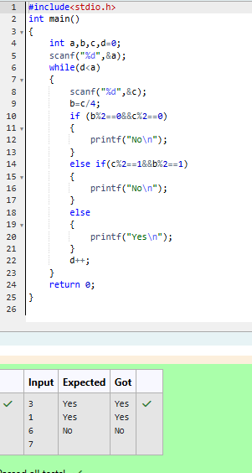

2. You are designing a poster which prints out numbers with a unique style applied to each of them. The styling is based on the number of closed paths or holes present in a given number. The number of holes that each of the digits from 0 to 9 have are equal to the number of closed paths in the digit. Their values are: 1, 2, 3, 5, 7 = 0 holes. 0, 4, 6, 9 = 1 hole. 8 = 2 holes. Given a number, you must determine the sum of the number of holes for all of its digits

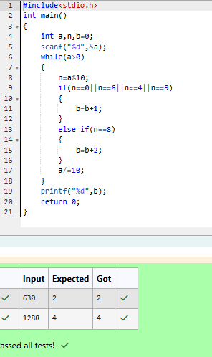

3. You are designing a poster which prints out numbers with a unique style applied to each of them. The styling is based on the number of closed paths or holes present in a given number. The number of holes that each of the digits from 0 to 9 have are equal to the number of closed paths in the digit. Their values are: 1, 2, 3, 5, 7 = 0 holes. 0, 4, 6, 9 = 1 hole. 8 = 2 holes. Given a number, you must determine the sum of the number of holes for all of its digits

